**MONOCLINIC** 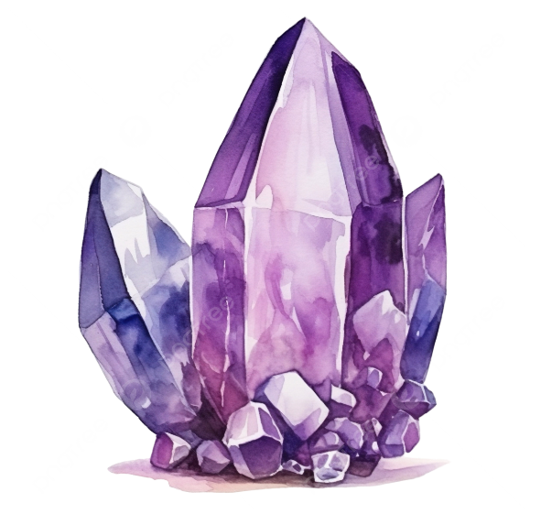

In crystallography, the monoclinic crystal system is one of the seven crystal systems. A crystal system is described by three vectors. In the monoclinic system, the crystal is described by vectors of unequal lengths, as in the orthorhombic system. They form a parallelogram prism.

 There are a total of seven crystal Triclinic, Monoclinic, Orthorhombic, Tetragonal, Trigonal, Hexagonal, and Cubic. Diamond is the hardest natural material. The study of the diamond is known as Gemology.

If you need spontaneity and flexibility in your life monoclinic crystals are ideal for you. Monoclinic crystals are here to teach us that it’s important to listen to feelings and emotions. Place them close to your third eye chakra to trust more your intuition.

**Monoclinic crystals** are characterised by three unequal axes of symmetry of which only two at 90 degrees and inner structure z in parallelograms.

**Their crystal properties are:**

-deeply cleansing  
-promoting clarity  
-support changes  
-help self-development

### If you are drawn exclusively to monoclinic crystals, you

-easily change your mind  
-are very flexible  
-like certainties in your life  
-are spontaneous